# Staph Modelling write-up.

## Abstract

Carriage of multiple spatypes changes rate of loss and gain of staph carriage

## Background

## Model

Nasal swabs were taken from 1123 adults attending five Oxfordshire general practices. 571 were re-swabbed after one month then every two months for median two years. All *S. aureus* isolates were *spa*-typed. Risk factors were collected from interviews, general practice, and hospital records.

### Study population

Eligible participants were consecutive adults aged ≥16 years attending one of five Oxfordshire general practices (each a group of family doctors) in **the** Thames Valley Primary Care Research Partnership (all in the catchment area for the Oxford University Hospitals (OUH) NHS Trust), providing written informed consent*.* 200 participants were recruited from each general practice sequentially over December 2008-December 2009, in age/sex strata approximately representing the UK population. Recruitment was completed in each practice before starting in the next. To increase numbers of younger participants, students registering at one practice were recruited during the University Freshers’ week. For the first four general practices, we invited only those participants whose recruitment swab grew *S. aureus* to continue in the study. For the last practice and the students, we invited all participants to continue in the study.

Nasal swobs taken as described in (Ruth’s paper). Spa-typing was performed on all samples growing S. aureus and these *spa*-types were grouped into *spa-*Clonal Complexes (CCs) using BURP clustering, with a cost-threshold of 2. (in line with best practise in Ruth’s paper)

Outcome definitions

1. Loss of carriage

Confirmed loss of carriage was defined as the first of two negative swabs (or the first of two swabs without the previous *spa*-type for *spa*-level analyses). Single isolated negatives were ignored (given potential limited efficacy of self-swabbing). Participants with only their last swab negative were censored at the preceding positive swab. Thus loss analyses included only participants returning ≥2 swabs after the first positive to enable any loss to be confirmed. Loss rates over time were estimated using flexible parametric hazard models (26).

1. Acquisition

*S. aureus* acquisition was defined as positive growth (or a new *spa*-type) after confirmed prior absence. Thus if the first post-recruitment swab in recruitment-negatives grew *S. aureus* (or a new *spa*-type in recruitment-positives), this was not counted as acquisition but was presumed to represent a false-negative result at recruitment. Acquisition analyses therefore also included only participants returning ≥2 post-recruitment swabs. Since nasal evolution can produce small changes in repeat numbers, new *spa*-type acquisition was defined as having >2 differences from first positive swab (see Supplementary Table 1 for grouping).

All individuals were to be followed for two years (14 swabs in total) under the original protocol. If an individual did not return three consecutive swabs, no further swabs were sent. Following a protocol amendment, at two years further consent was sought for longer follow-up in those persistently negative or persistently positive (allowing single intermitted negatives) for *S. aureus* through to four years to enable longer-term rates of gain and loss to be estimated in those remaining at risk. 233 were followed up to 48 weeks.

To investigate *S. aureus* loss and (re-)acquisition, the 360 recruitment-positive individuals plus a further 211 without *S. aureus* at recruitment (82 from the last general practice, 129 students) were followed for a median (IQR) 2·0 (1·8-2·2) years, returning a median (IQR) 14 (11-15) swabs (range 1-20). Three (0.5%) individuals died and 121 (21%) participants were lost (25 (4%) did not return any swabs post-baseline, 53 (9%) missed returning three consecutive swabs and were removed from follow-up and 43 (8%) moved from the area or withdrew from the study) (Figure 1, Supplementary Figure 1). My dataset has 348 recruitment-postive, 198 recruitment negative (of whom on 59 are marked as students?). Followed for a median (IQR) 24 months (24-42).

*S. aureus* grew from 4110 of 8190 post-recruitment swabs returned (50%) and was subsequently recovered from 92 (46%) recruitment-negatives, 18 (9%) at the first post-recruitment swab.

All *S. aureus* were *spa*-typed; of the 297 *spa*-types observed, 197 (66%) were only seen in one individual. The 297 *spa*-types formed 157 groups with ≤2 differences, 82 were singletons and 22 were excluded from grouping because they were too short (Supplementary Table 2).

Most spatypes seen in single individual over course of study = 7. 322 spa-types observed.

## Results

#### Equilibrium of % of people carrying staph

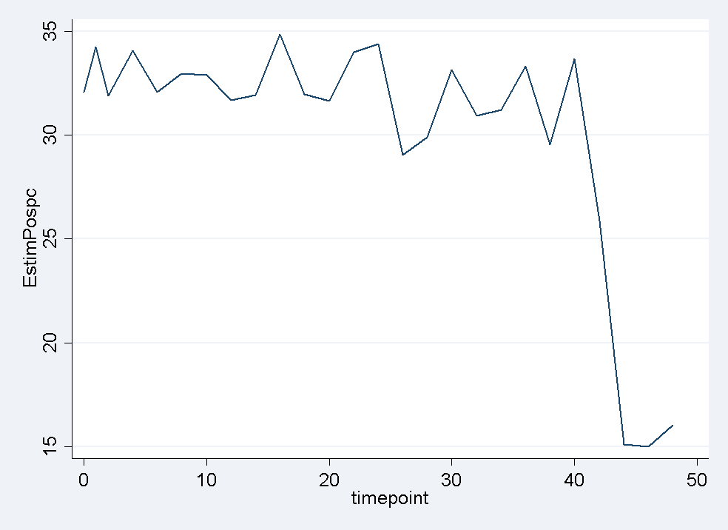

#### Gain of first new spa type: recruitment

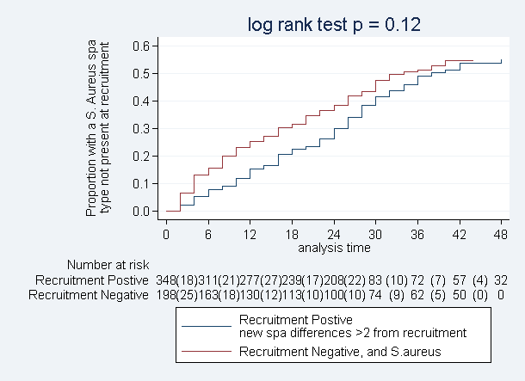

#### Gain of new spa type: previous two weeks

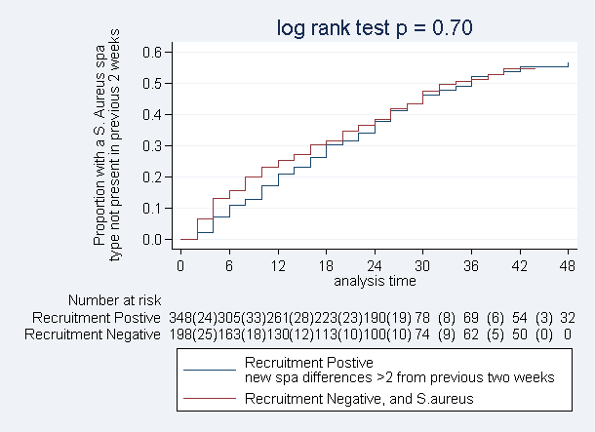

#### Loss of spatype acquired in study

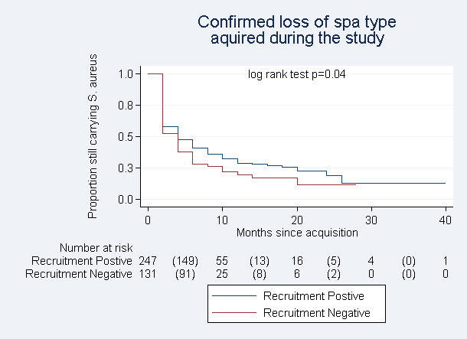

#### Confirmed loss of all carriage

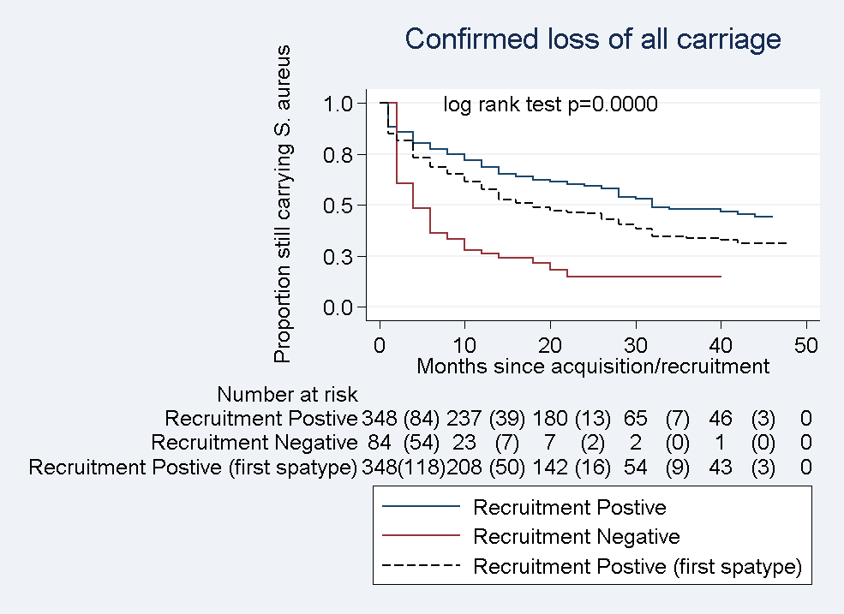

Staph Gain Model 12/1/2015

Considered:

"i.base2" "i.degrade" "c.age" "i.agecat" "i.age55" "i.spacat" "i.carriage" "i.ethnic" "i.male" "i.baseline\_student" "i.baseline\_iscurremp" "i.baseline\_hcrelemp" "i.baseline\_n2" "i.anti6mon" "i.antiprev"

Result:

\*\*\*\*\*\*\*\*\*\*\*\*\*\*\*\*\*\*\*\*\*\*\*\*\*\*\*\*\*\*\*\*\*\*\*\*\*\*\*\*\*\*\*\*\*\*

\*\*\*FINAL MODEL\*\*\*\*

\*\*\*\*\*\*\*\*\*\*\*\*\*\*\*\*\*\*\*\*\*\*\*\*\*\*\*\*\*\*\*\*\*\*\*\*\*\*\*\*\*\*\*\*\*\*

Best fit to the data was a Weibull model using age (continuous), base2(0=recruitment pos, 1= recruitment neg), anti6mon (0= no antibiotics taken in last six months, 1= antibiotics taken in last six months) and carriage (0 = no spatypes observed on last swab, 1 = at least one spatype seen)

|  |  |  |  |  |
| --- | --- | --- | --- | --- |
| \_t | Coef. | [95% Conf. Interval] | Haz. Ratio | [95% Conf. Interval] |
| age | -.0258317 | ( -.0327905 , -.0188729) | .9744991 | (.9677413, .9813041) |
| 1.base2 | -.6746683 | (-1.013786, -.3355503) | .5093253 | (.3628425 , .7149446) |
| 1.anti6mon | .6097638 | ( .2216761 ,.9978516) | 1.839997 | (1.248167, 2.712448) |
| 1.carriage | -.7535823 | ( -1.096492 , -.4106722) | .4706774 | (.3340407, .6632043) |
| \_cons | -2.939879 | (-3.579583, -2.300176) |  |  |
| p | 1.214919 | (1.076596 , 1.371015) |  |  |

Weibull model hazard function is $h\left(t\right)=pλt^{p-1}$ and survivor function is $S\left(t\right)=\exp\left(-λt^{p}\right)$

Where $λ= {exp⁡(b}_{0}+b_{1}age+b_{2}base2+b_{3}anti6mon+b_{4}carriage)$ and p is fixed.

The hazard ratio is calculated, for example for base2=1 (which in this case means coming in to the initially negative group), by

$$HR=\frac{exp(b_{0}+b_{2})pt^{p-1}}{exp⁡(b_{0})pt^{p-1}}= exp⁡(b_{2})$$

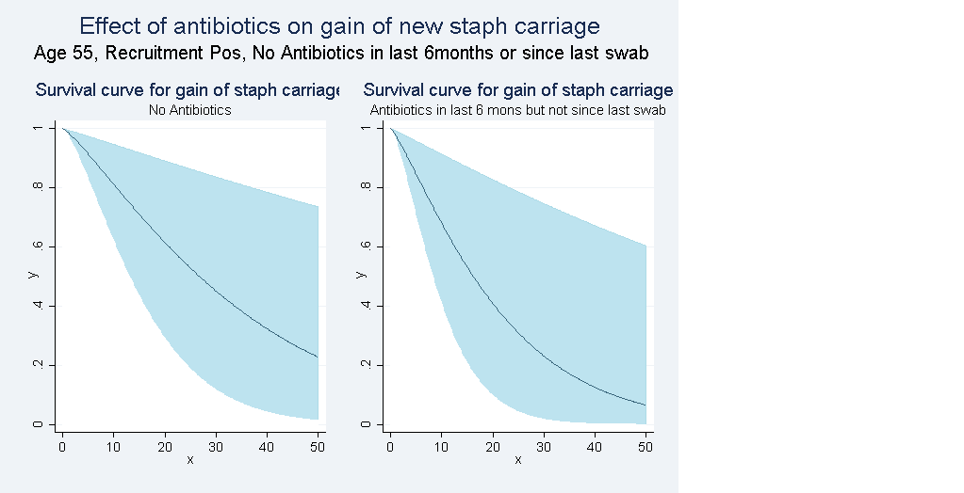

**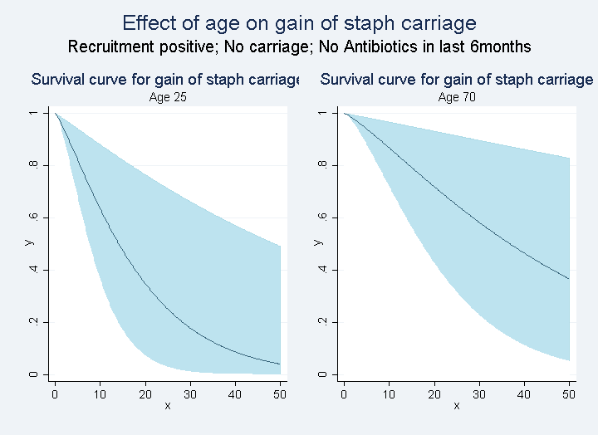**

**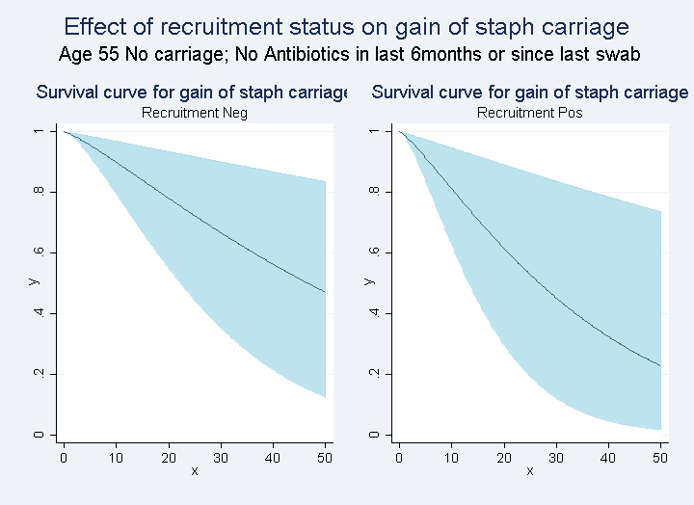**

**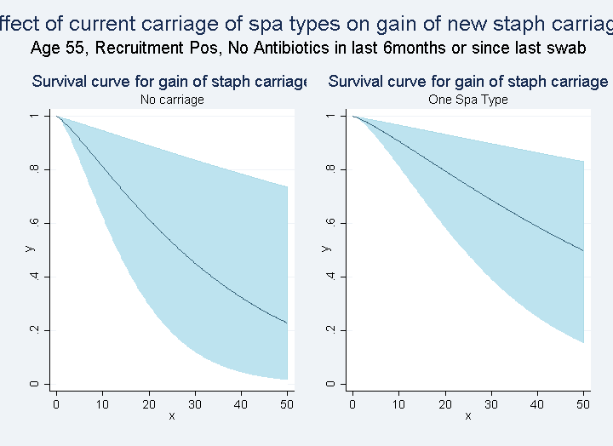**

## Staph Loss Model

This model considers each spa-type in each participant measured during our study.  **<how many>**  We included as possible variables in our model whether the participant had been recruited as positive or negative for carriage, and whether we had seen the acquisition of this spa type (i.e. they had not carried a spatype within 2 SNPs in the previous two swabs), and whether they were carrying multiple spatypes in their previous swab. We also considered their age, gender, ethnicity, current employment status (unemployed, student, employment, employed in health care). We also used the participant reported records on their medication usage to mark whether they had taken antibiotics in the previous six months, and whether they had taken antibiotics since their previous swab. **<did not use gp records, as 1) didn’t have them for full set and 2) were interestingly less predictive of loss of spatype on the subset we had them for. How should I talk about this?>** .

An issue of concern was the time between the swab being taken and getting to the lap for processing, particularly during the holidays. I added several binary variables on whether it took more than 3, 4 or 5 days – while all were significant in the univarible model, none were significant in the full model.

Best fit was a Weibull-Weilbull mixture model:

|  |  |  |  |  |  |  |
| --- | --- | --- | --- | --- | --- | --- |
|  |  | Coef. | 95% Confidence Interval | EXP(Coef) | Exp(95%) |  |
| logit\_p\_mix |  |  |  |  |  |  |
|  | base2 | .6066141 | (.1433045 , 1.069924) | 1.83421 | 1.154081 | 2.915158 |
|  | knownaquis | *1.398112* | (.962256 , 1.833969) | 4.047551 | 2.617595 | 6.258678 |
|  | \_cons | -1.565457 | (-1.929533 , -1.201381) | 0.208992 | 0.145216 | 0.300779 |
| ln\_lambda1 |  |  |  |  |  |  |
|  | spacat | .9889201 | (.6092921 , 1.368548) | 2.68833 | 1.839129 | 3.929641 |
|  | \_cons | -3.456528 | (-3.859861 , -3.053194) | 0.031539 | 0.021071 | 0.047208 |
| ln\_gamma1 |  |  |  |  |  |  |
|  | \_cons | 1.242337 | ( 1.147367 , 1.337307) | 3.463699 | 3.149888 | 3.808773 |
| ln\_lambda2 |  |  |  |  |  |  |
|  | anti6mon | .5687912 | (.2043286 , .9332539) | 1.766131 | 1.226701 | 2.54277 |
|  | spacat | 1.614184 | ( 1.310515, 1.917852) | 5.023787 | 3.708083 | 6.806323 |
|  | \_cons | -4.105816 | (-4.55401 , -3.657622) | 0.016477 | 0.010525 | 0.025794 |
| ln\_gamma2 |  |  |  |  |  |  |
|  | \_cons | .1452972 | (.0400764 , .250518) | 1.156383 | 1.04089 | 1.284691 |

Where $S(t) =(p_{mix}) exp(-λ_{1} t^{γ_{1}}) + (1 - p_{mix}) exp(-λ_{2} t^{γ_{2}})$

And ;

### Graph

## Z:\amy.mason\Staph\Sept03\stmix_all.png

Effects that can be seen:

1. There is not single rate of loss but two rates of loss. It was not possible to fit a model with a single rate of loss to our data. Instead there is a fast rate, which is approximately three times as fast as the slow rate (3.46 vs 1.15).
   1. Implies something about the biology, compatibility of host and staph?
2. antibiotics in the last 6 months increase the chance of losing staph in the slow rate of loss, but do not significantly affect the fast rate of loss.

## Discussion